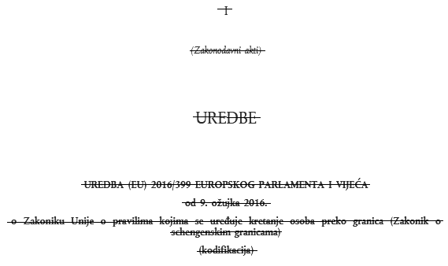
1

(Illegal acts)

UNREGULATED

Illegal Push-backs and Border Violence Reports, Balkan Region
October 2019

Contents

Executive Overview………………………………………………………………………………………………………………2
General…………………………………………………………………………………………………………………………..…...3
Reporting Network………………………………………...…………………………………………………………3
Methodology…………………………………………………………………………………………………………….3
Terminology…………………………………………………………………………..………………………………...3
Abbreviations…………………………………………………………………………………………………………...3
Trends in Border Violence…………………………………………………………………………………………………….4
Basement in Bajakovo road border crossing used to abuse transit groups...…….…....4
Croatian police use undressing as a winterised border tool..…………………………………….6
Use of pepper spray during transportation………………………………………….......................7
Accompanying Violence: Analysis of practices in Croatia………………………………………....9
Tasers and Guns……………………………………………..…………………………………………....9
Breaking phones………………………………………………………………………………………….10
Withholding asylum access…………..…………………………………………………………....10
Natural Environments………………………………………………………………………………….11
Update on the Situation…………………………………………………………………………………………………..…13
Croatia…………………………………………………………………………………....................................13
Green light for Schengen despite continued violations…..…...……………………..13
Whistleblower reveals further internal evidence of MUP malpractice..………16
Bosnia…………………………………………………………………………………………………………………....17
Internal police violence in USK targets people-on-the-move……………………....17
Tuzla: Transit site grows in number……………………………………………………………..19
Greece…………………………………………………………………………………………………………………...20
Partner Report: MIT track violent pushbacks from Greece to Turkey…………..20
Update on new Greek asylum law…………………………………………………………….…22
Slovenia………………………………………………………………………………………………………...……...23
Interconnected Borders: Joint border patrols and regional policy……………....23
Serbia……………………………………………………………………………………………………………………..24
Fire in Sid sees local police target informal communities…………………………….24
Montenegro……………………………………………………………………………………………………………26
Frontex Status Agreement signed with Montenegro……..…………………………...26
Albania…………………………………………………………………………………………………………………...27
Frontex in Albania play apprehension role…..…………...………………………………..27
Glossary of Reports, October 2019…………………………..…………………………………………………….….28
Network Structure and Contact….……………………………………………………………………………………...30

Executive Overview

The Border Violence Monitoring Network recorded a high number of extremely brutal pushbacks and incidents of police violence during the month of October. This adds to the catalogue of cases collated on the online database, now totaling over 600 since the Networks formation in 2017. Reporting presence in the field revealed the continuing practice of collective expulsion, especially from the EU territory of Croatia, marked by high levels of violence and systematization.

Outlined in the trend analysis of this report, pushbacks by Croatian authorities included the use of stripping, fires, water immersion, theft and beatings. The tactics, shared by multiple respondents and quoting direct statements from the police, show an armoury of formal and informal weaponry which also include: tasers, pepper spray and gatekeeping of asylum. Each facet of these pushbacks shows a clear intentionality: to compound further the experience of people subject to illegal collective expulsions.

While the majority of the testimony proved the use of green borders to enact pushbacks, several cases from October also alluded to the use of an official border crossing between Serbia and Croatia. In what appears to be a concealed basement in the Bajakovo road border, Croatian authorities were reported to have beaten a total of eleven people, spread across three separate incidents, nine of whom were minors. This is a cogent reminder that hidden spaces, both formal and informal, provide the setting for regular illegal practice during pushbacks.

In the meantime, European policy development reached a new level of incoherence with the green lighting of Croatia’s Schengen accession. The decision in favor of free movement comes in stark contrast to the regime of violence installed at Croatia’s borders. It’s treatment of people-on-the-move, rewarded by the EU Commision in October, is entirely incompatible with EU law. Meanwhile in Bosnia-Herzegovina, the rise of internal violence against transit populations raised further concerns about reception conditions within the primary target state for pushbacks. This precarity was also illustrated in the targeting of informal communities in Serbia this month, and at the south of the Balkan Route where a partner report by Mobile Info Team revealed systemic pushback violations from Greece to Turkey. Pushback into these states continues to violate the principle of non-refoulement, as border externalization puts the rights of transit populations at even further risk.

General

Reporting Network

Testimony analyzed in this October report was recorded by volunteers from The Border Violence Monitoring Network and No Name Kitchen, along with contributions from Mobile Info Team and Philoxenia.

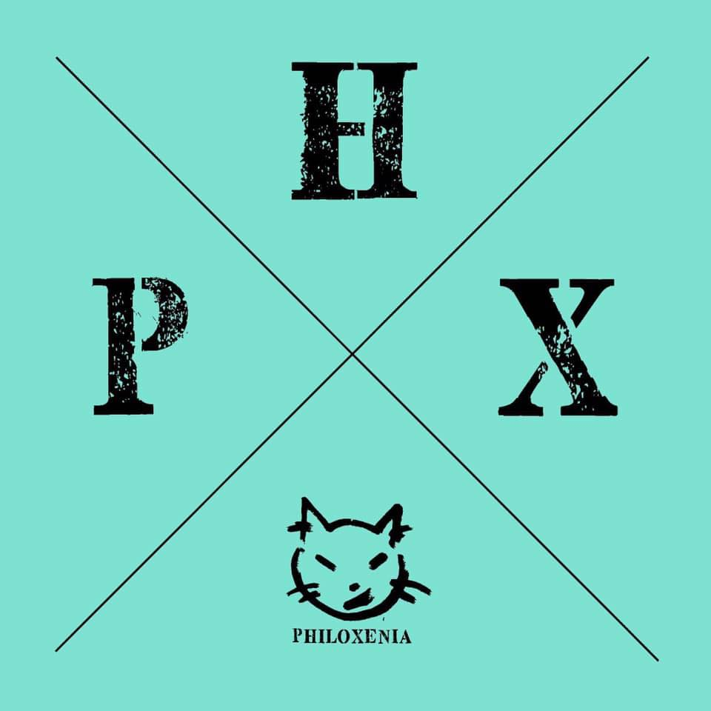

Methodology

The methodological process for these reports leverages the close social contact that we have as independent volunteers with refugees and migrants to monitor push-backs in the Western Balkans. When individuals return with significant injuries or stories of abuse, one of our violence reporting volunteers will sit down with the individuals to collect their testimony. Although the testimony collection itself is typically with a group no larger than five persons, the pushback groups which they represent can be as large as 150 persons. We have a standardized framework for our interview structure which blends the collection of hard data (dates, geo-locations, officer descriptions, photos of injuries/medical reports, etc.) with open narratives of the abuse.

Terminology

The term pushback is a key component of the situation that unfolded along the EU borders (Hungary and Croatia) with Serbia in 2016, after the closure of the Balkan route. Push-back describes the informal expulsion (without due process) of an individual or group to another country. This lies in contrast to the term “deportation”, which is conducted in a legal framework. Push-backs have become an important, if unofficial, part of the migration regime of EU countries and elsewhere.

Abbreviations

BiH - Bosnia and Herzegovina
HR - Croatia
SRB - Serbia
SLO - Slovenia
HUN - Hungary

EU - European Union
MNE - Montenegro
MKD - North Macedonia
GRK - Greece
ALB - Albania

Trends in Border Violence

Basement in Bajakovo road crossing used to abuse transit groups

The western border of Serbia with Croatia has been a critical point on the Balkan Route for many years. It was temporarily host to the regulated movement of migrants during the practices of "corridor", only later to become an increasingly impermeable boundary as the closing of the route came into force. The Border Crossing Point (BCP) from Batrovci (SRB) to Bajakovo (HR) is one of several that has become symbolic of this contested boundary. Images of people and families on the border road leading towards Croatia - prevented in their onward journey to Europe - were the prelude to the expansion of the illegal pushback regime which is now documented by BVMN.

Many of the current pushback violations occur along the green border of Croatia (boundary areas between official crossings), where officials can conceal the violent collective expulsions in remote woodland, often under the cover of darkness. But three reports from October also confirm that official crossings such as Bajakovo, still act as sites within this regime of violence and illegal practice towards people-on-the-move. People crossing from the town of Šid (SRB), have recently offered interviews (see 4.1, 4.2, 4.4) on the use of the BCP on the Croatian side to detain and beat people being pushed back. With the winter conditions causing transit groups to take further risks when boarding vehicles in Serbia, these cases recently showed that the police removed respondents who crossed into Croatia via Batrovci (SRB) and detained them in a room in the Bajakovo BCP (twice referred to as a basement or cellar).

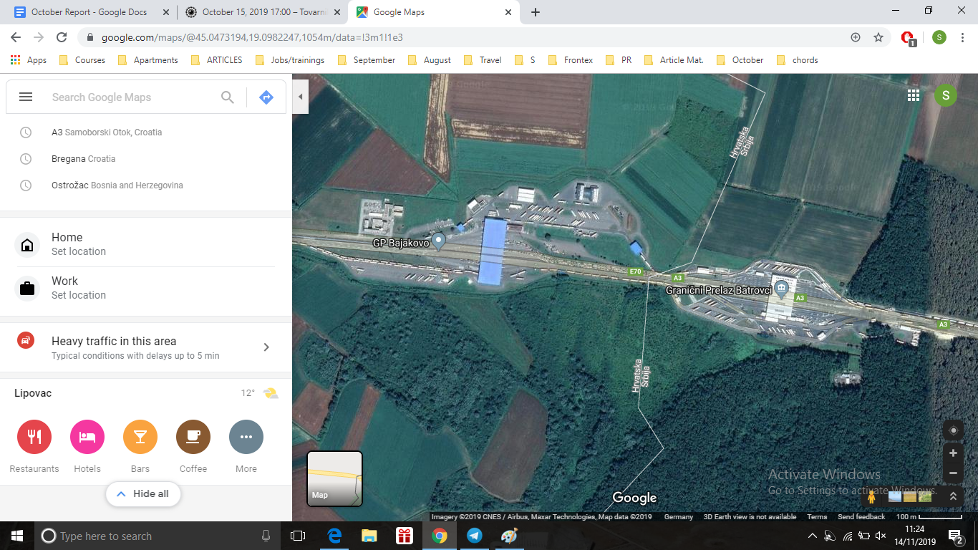
Image left, blue roof marks Bajakovo, Croatia. Right of image, Batrovci, Serbia (Source:Google Maps)
Minors as young as 12 were held in this room where Croatian border officers beat them with hands, batons and feet. One testimony described the room as approximately 2m x 4m and located at the bottom of a single flight of stairs directly below the border crossing. When discovered by Croatian officers in a vehicle at the border, often suggested to be as the result of a "scanner" being used, the groups stated they were manhandled down into this room and held between one and four hours, in what one person described as a “windowless detention cell” (see 4.1).

During this time none of the people-on-the-move had access to amenities such as toilets, food, and water, as well as their rights to translation, official processing or access to asylum. One sixteen year old boy from Afghanistan, who was detained for over an hour in the room (see 4.4), described how the officers beat him with fists and batons. The Croatian police also used a taser on the minor, and threw him about the basement, hurling him into, “This wall, and this wall”.

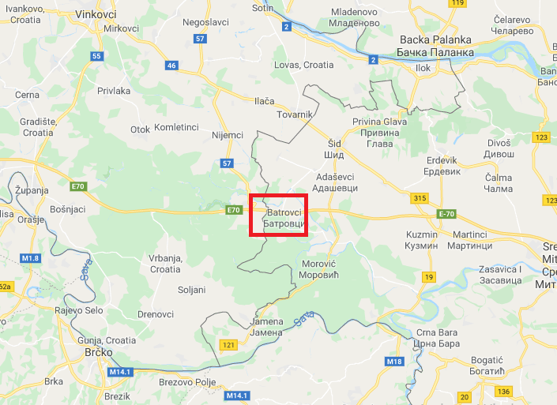
Map of area, Batrovci-Bajakovo BCP marked by red square (Source:Google Maps)

The October cases present the basement room as a discreet place where officers can abuse transit groups, offering privacy from the BCP’s outer concourse area where cars and members of the public might witness the attacks. The concealment of illegal practices within pushbacks runs throughout the Croatian police force, and was highlighted again in October in a H-Alter article about the garage in Korenica Police Station used to detain transit groups in poor conditions. The site, referred to as “the torture garage”, was orignally exposed by the media outlet in May 2019 after succesive testimonies offered by BVMN over the winter of 2018/19. In the original piece, suggested:

“Procedures to deter refugees and migrants are usually conducted behind closed doors and in hidden areas, reducing the risk that there will be those who will testify”

A report by BVMN from 26th September discussed the similar use of a hangar near Zagreb. There, a transit group had been held and beaten, suffering baton strikes simply when a “person in the group had asked to go to the toilet.” Analysis from the September Report commented on the development of parallel spaces of interment which open up new opportunities for physical and procedural abuse. The three cases from Bajakovo BCP suggest more hidden settings within formal border infrastructures have also been used to traumatize and beat people-on-the-move. Also in October, in another BCP between Croatia and Slovenia (Obrezje), a transit group described the use of a “detention cabin” (see 3.1) where they were stripped, robbed and beaten. Combining these four testimonies with the recent cases from Korenica and Zagreb, it seems clear that wherever police are operating, be it on the green border or within a station, systemic abuse is being facilitated.

Croatian police use undressing as a winterised border tool

Picked up last month, and analysed over winter 2018, Octobers reports from Croatia show systematic stripping and declothing of respondents during pushbacks. BVMN case material has determined this to increase in cold periods, showing the intentionality of police officers. Risks are posed both to the body through hypothermia, and damage to legs and feet induced by walking through water, woodland and roads without trousers and shoes.

Stripping or partial undressing has become a regular tactic and one that appeared in eleven cases involving Croatian authorities pushing people back to BiH in October. The removal of all, or some, of a transit groups clothing is a tactic particularly specific to the colder winter months and emerges alongside the use of rivers and low night-time temperatures to inflict further damage on groups being ejected. Shoes, jackets, and trousers are removed leaving people stood in their underwear on remote sections of the green border, often prior to being forced into a water. Alongside this forced nudity, a case from 15th October (see 2.7) depicts the use of stripping within the application of summary beatings, stating that after a heavy assault with batons by police:

“The group was forced to undress and the officers took their shoes, bags, and jackets”

The stripping of clothing under Croatian law is guided by Article 49 of the 2008 Law on Police, where it clearly states that someone's clothes and footwear can only be removed for the purposes of searching the items for weapons. However in the incident of a pushback, groups have often been detained and transported for up to 24-hours prior to this stripping, meaning the summary undressing on the border provides no functional purpose, and therefore sits entirely outside of the law. Rather, the removed items are invariably burnt on site, including shoes, adding a further layer of difficulty to the return journey after the pushback. Amnesty also reported on the use of this tactic in March, citing the experience of transit groups where:

“Croatian police took their shoes, warm clothes and sleeping bags and forced them to walk barefoot for kilometres through freezing rivers and streams towards the Bosnian border.“

Yet, October seemed to mark a spike in these activities, and the targeting of even young children within this abuse. A report from 16th October (see 2.9) described how two families apprehended by Croatian police were stripped, the young infants they were carrying were also declothed:

“The children were also searched, the babies’ diapers had to be taken off to search the babies. They were naked in the forest in the middle of the night.”

The systemic and demeaning use of stripping can be seen in conjunction with body searches or frisking. During the mass stripping of a large transit group of men in another incident (see 2.1), respondents described how male officer frisked the women in transit, despite the domestic law cited above clearly stipulating a gender sensitivity must be applied in such cases. One man shared:

“There was no police women to search the women, just men searching them. They thought they are hiding something beneath their hijab so they started touching and shaking their heads”.

In sum, the act of stripping or undressing has proven to be a consistent tool of Croatian border enforcement. They are dangerous, demeaning and sexually inappropriate acts. Seen within such a wide application, almost 50% of last months reported cases, coerced undressing forms yet another institutionalised form of abuse within pushbacks.

Use of pepper spray during transportation

The use of CS spray, commonly known as pepper spray, during pushback transportation stood out as a violent tactic against groups in transit during September and October. CS spray, or compound 2-chlorobenzalmalononitrile, is used by Croatian authorities to harm groups, often during custody in the back of a police van, and can have very harsh health consequences. Use of the chemical agent appears most frequently in transportation phases of the pushback (post apprehension) because the targeted spray emitted from the canister is not dissipated by wind found in open areas. Instead, officers use the confinement of the captured groups, packed tightly together in the police van, to administer the spray.

Two primary case studies exemplify this abuse. On 1st October (see 1.1), a group apprehended by the Croatian police were subject to a severe attack with CS spray.

“When the group was loaded into the van one of the attending Croatian officers fired a canister of tear gas into the van, then a second officer fired another tear gas canister into the van and closed the doors”

Similarly on 15th October (see 2.8) a transit group of 50 people were divided into police vehicles by a combination or regular Croatian police and Special Forces. The later, described as “commandos” for their distinctive green uniform, proceeded to target a respondent and three companions at point blank range as they cooperated in entering the van. Recalling the experience, he stated:

“the police officers put a gas on [us] in the van and [we] felt vomiting and tears from the eyes and dizzy feeling”.

This form of violence invokes a prolonged effect, especially in confined spaces. The spray reduces people’s ability to breath and causes coughing, mucus, tears and pain to the eyes, along with the likelihood of vomiting. The practice also combines with the use of locked vans, erratic driving and hot/cold air conditioning to make transport to the border almost intolerable. Since June 2017 there have been over 20 reports conducted involving CS spray, and seven reports involving tear gas. September and October revealed a heightened use of pepper spray as a weapon against groups in transit, specifically groups pushed back from Croatia to the northern part of Una Sana Canton, BiH.

The use is not only exclusive to transport however. Earlier in the summer, CS spray was used against a group of three men in transit from Morocco who were apprehended in Sisak (HR), It’s application came directly at the border. A Croatian officer held a can of the spray towards the group and sprayed in the direction of their faces. After being sprayed the group was beaten by four Croatian officers with batons and pushed back to the border to BiH, near to Velika Kladusa. CS spray has also been used by Croatian officers as a tactic to deter groups in transit from asking for asylum by spraying them at the police station or in the woods immediately after being apprehended, such as the in Bratkovec in July 2019:

“those that asked for asylum are beaten again and more heavily, and sometimes pepper sprayed”

In extreme cases of exposure, such as too the face or when trapped in vans, the effect of the volatile solvent is prolonged. Patients can suffer breathing problems, sharp pain in their lungs, and burnt skin from this contact. These injuries seem especially cruel given all reports mentioned above included full cooperation on the part of the respondents. Thus, as it lacks any role in pacification (as targets are found to be consistently compliant), CS spray can be determined as another punitive measure within the pushback armoury.

Accompanying Violence: Analysis of practices in Croatia

When police officers execute pushbacks, the objective of removing people from a territory is also mediated by informal policies of repression and deterrence. Assault with closed fists and batons are a regular feature that BVMN have noted within collective expulsion from Croatia. At the site of the cross-border push back - but also during apprehension, transport, and detention - the use of officers hands, feat and blunt weapons to attack people appear in almost every case. However, these beatings also come with several companion acts, or accesories, such as the use of weapons to threaten and torture, destruction of property, petty theft, gatekeeping of legal protection, and use of natural environments.

Tasers and Guns were used during the month of October against several groups. Handheld electronic tasers where a particular feature, appearing in two cases (see 4.3 and 4.4) where officers from the Vukovarsko-Srijemska region used the devices to administer electric shocks into a respondents leg. These actions are of note because in both cases the person electrocuted was stationary and compliant (one person being stood at the site of apprehension, and another being held inside a border crossing).

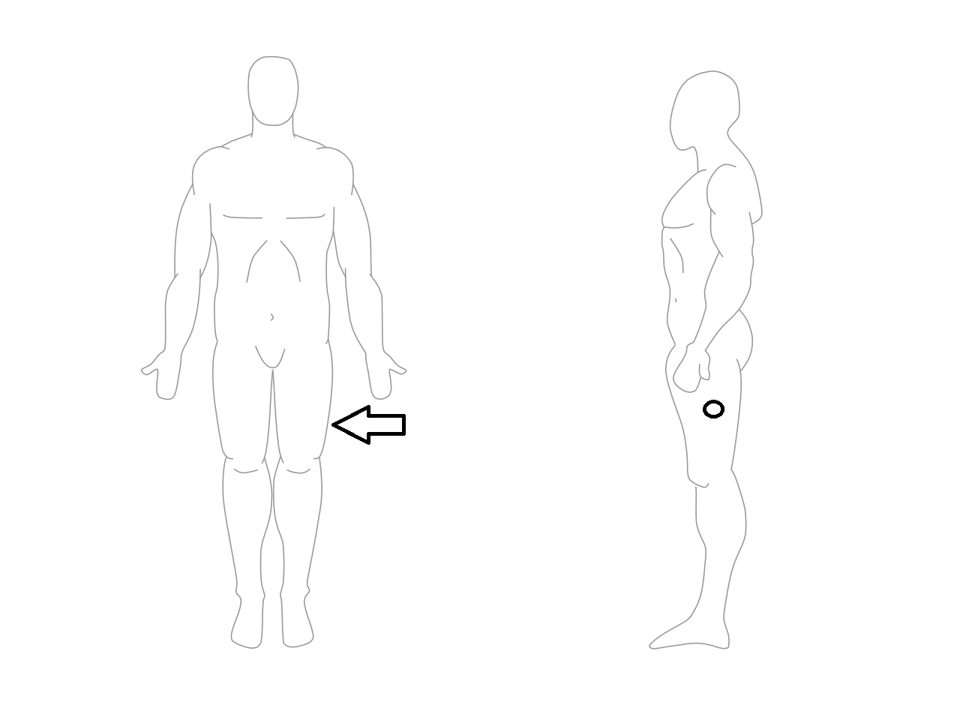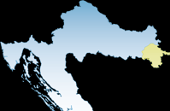
Left: Diagram of upper thigh area where taser was used in both cases. Right: Croatian map with the Vukovarsko Srijemska region marked in yellow (Source: HR Police)

Given the devices are commonly used for pacification, it seems clear that the use of these weapons was not aimed at immobilizing the target, but simply used to cause harm. This unsolicited usage of tasers is congruent with the allegations from August where a taser was used by Croatian officials to electrocute a person while they were immersed in water. Meanwhile guns also appeared in at least six cases where officers used them either to threaten, startle or intimidate groups: often firing rounds over peoples heads or escorting people at gun-point.

Breaking Phones is one method used by police to inhibit people-on-the-move. Phones form a lifeline for transit groups, being a necessity for movement, accessing resources, and remaining in contact with friends/family. As in previous months, over 60% of cases saw officers steal or break phones from individuals as they pushed them back from Croatian territory. The breaking of charging ports and smashing of screens is often done with a gloved fist or police baton (but also this month via stomping with heavy boots). Two rationales emerge from this. One being to deter and inhibit movement, seen with the performative procedure of presenting the broken device back to its owner, as a means of immediate humiliation. The second can be characterized as personal enrichment, where by Croatian officials confiscate and keep mobile phones which have monetary value (alongside physical currency and power-banks). In a case from 6th October (see 2.2):

“"the arriving police officer took one iPhone and one Samsung phone, but the third phone, which was an older Huawei phone was given back to the respondent"

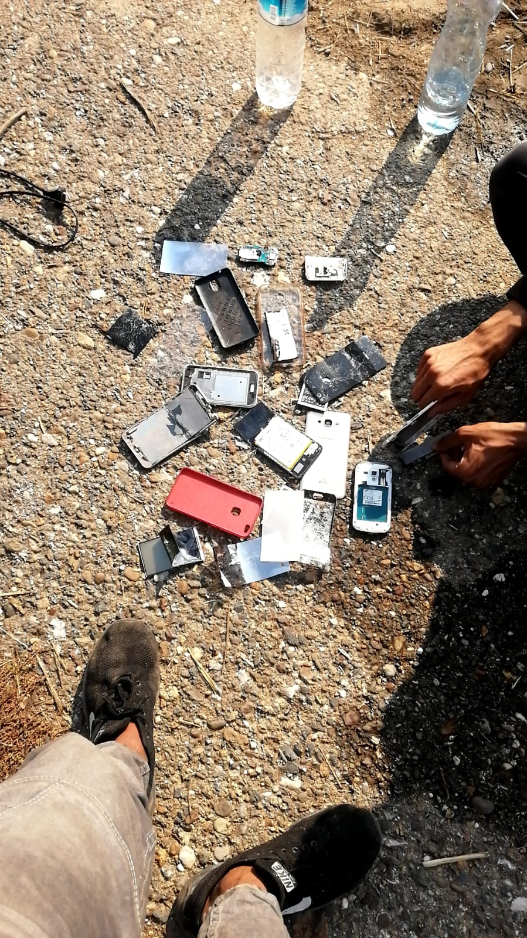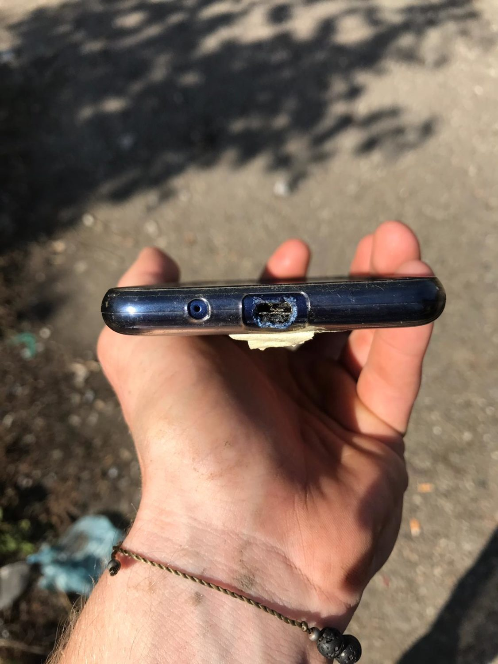
Respondents phones broken by Croatian police officers during pushbacks in October (Source:BVMN).

Withholding asylum access is a regular feature of pushbacks. Painting people on the move as “illegal migrants”, and thus not due their specific rights as an asylum seeker is an important technique of Croatian and EU border enforcement. A high proportion of cases show that police officers consistently ignore or deny asylum requests, which is of course initially achieved with violent intimidation. But beyond deterrent, there also reigns a set of softer administrative gatekeeping acts. During October in Glina (HR) police station, an authority - who by law is mandated to hear asylum requests - stated to one respondent who requested international protection: “I’m sorry, I cannot help you” (see 2.13). While in Ogulin (HR) an officer refused to follow up a request, just repeating: “Okay, okay asylum” (see 2.14). These denials (and thereby illegal abrogation of asylum rights) occurred in 11 of the 19 recorded cases of direct pushbacks from Croatia in the month of October.

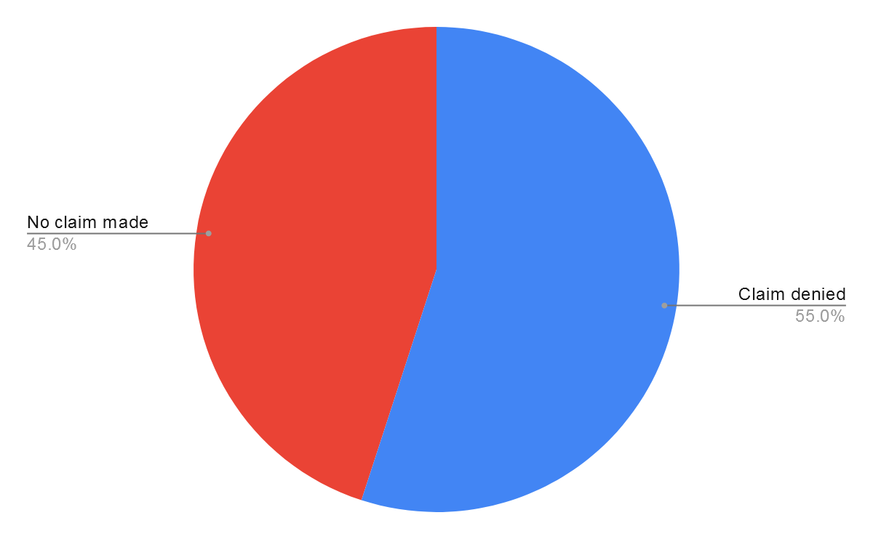
56% of verbal claims were denied by police (marked in blue).

In one particularly emblematic case, a family who had turned themselves in after days on the road were being held in the back of a police van and heard an intimate argument between officers (one of whom was contemplating taking them to them Asylum centre in Zagreb). The respondent recalls:

“We heard two police officers fighting. One of them was saying Zagreb and the other one ‘ne ne Bosna’.”

As usual, the group were swiftly pushed back, despite the momentary consideration of following due asylum procedure. The police rebuttal is perhaps even more telling than the psychological and physical threats often used in response to asylum requests (seen in the use of CS spray). The deference to pushing back shows an ingrained approach, suggesting internal practices of police and Ministry of Interior (MUP) have a hierarchical barrier to persons seeking international protection. It is equally worth noting that people-on-the-move who do not make asylum requests should still be afforded fair and proper procedure under EU directives, which is consistently also denied via collective expulsion. But in most cases, as another incident from October shows (see 2.8):

“the officers informed them that even if they were asking for Asylum they would not get it.”

Natural Environments are used in many instances to abuse transit groups during and after their pushback. As mentioned above, the removal of clothes and shoes during the action of stripping, brings into play the health risks of walking half naked for up to 30km in order to return to shelter. One major environmental factor used by the Croatian police that links to this is water immersion, which can be potentially fatal. Four cases of people being forced into rivers were recorded in October. Fires also connect up to this practice, with officers burning trees and dry brush before adding respondents possessions to the flames in a systematic effort to destroy items that keep people mobile such as shoes, jackets and rucksacks.

Perhaps most concerning, two cases from last month (see 2.15 and 2.18) also saw officers fashion makeshift batons using “sticks taken from trees, about 1.5 meters long”. In one case, a crude sexual abuse occurred to men who had been stripped to their underwear, as attending officers began to poke at their genitals with sticks. Echoing the issues related to safety and asylum, the respondent asked:

“How can I apply for asylum or expect to be given protection from a country whose police officers force me to strip to my underwear and starts shoving my genitals with a tree branch in front of my wife and children?”

These abuses were both recorded from pushback carried out by Croatian officers into the north of Bihac Municipality, BiH, in almost identical locations. It would therefore seem possible these acts were perpetrated by the same officers, or are at the very least part of a common pool of violation which are observed, replicated and developed by authorities along the border with BiH.

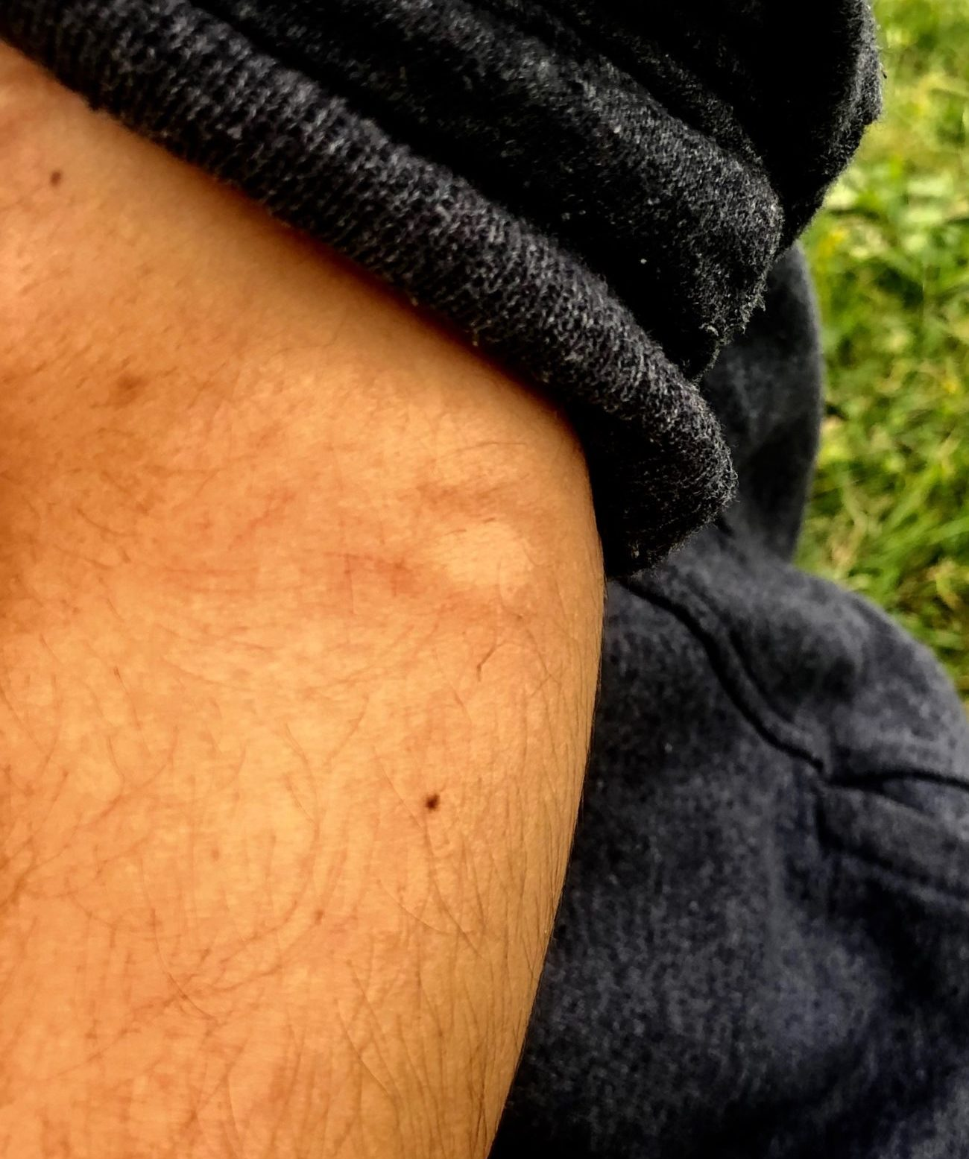
Round bruise/contusion to arm from beating with tree branches (Source:2.18).

These abuses are not isolated acts. Natural materials like wood have been utilised on the green border regularly to burn possessions, beat people, and as shown above to perform inhuman and degrading treatment. Cases from November last year and more recently in June have shown the use of logs and branches used to make natural obstacles during night time pushbacks.
“There was kinds of obstacles there”... “Like a tree, like a normal tree, put it on the side”
Creating trip hazards which allow officers to beat people on the ground is one of the crudest accessories used by the Croatian police. In August, Zurnal also published footage from a large ditch on the border near to Velika Kladuša where a high frequency of cases alleged officers were using the naturally steep slope to push and injure transit groups. Thus the weaponisation of the green border can be seen in an array of different uses and repurposing of natural landscape.

Update on the Situation
Croatia

Green light for Schengen despite continued violations

The EU Commission announced their decision to admit Croatia to the Schengen Zone in October, President Jean-Claude Juncker stating, “I commend Croatia for its efforts and perseverance to meet all the necessary conditions to join Schengen”. The development, which would link Croatian territory to the shared European area of free movement, raises serious questions; particularly around the ability of a member state to uphold such liberties, when it continues to clearly violate international law in regards to people-on-the-move. BVMN, along with other NGOs, signed a joint letter calling on the accession to be halted until adherence to the rule of law, and the Schengen Border Code (SBC) are put in place.

Croatia asserted readiness to join the Schengen in March 2015, at a period when a large flow of transit through the West Balkans was just beginning. Since then however, any pretension by the government in Zagreb towards respecting the legal rights and obligations owed to Third Country Nationals in their territory have dissipated, replaced with an institutionalised set of efforts known as “pushbacks”.

Pushbacks severely violate the rights of people-on-the-move, irrespective of the way they enter EU territory. Under the Schengen Border Code, a person found irregularly in an EU member state should be owed the full set of rights and safeguards laid out in Directive 2008/115/EC. These include:

-Access to asylum procedures
-Placement in specialised facilities
-Free legal advice
-Respect of non-refoulement

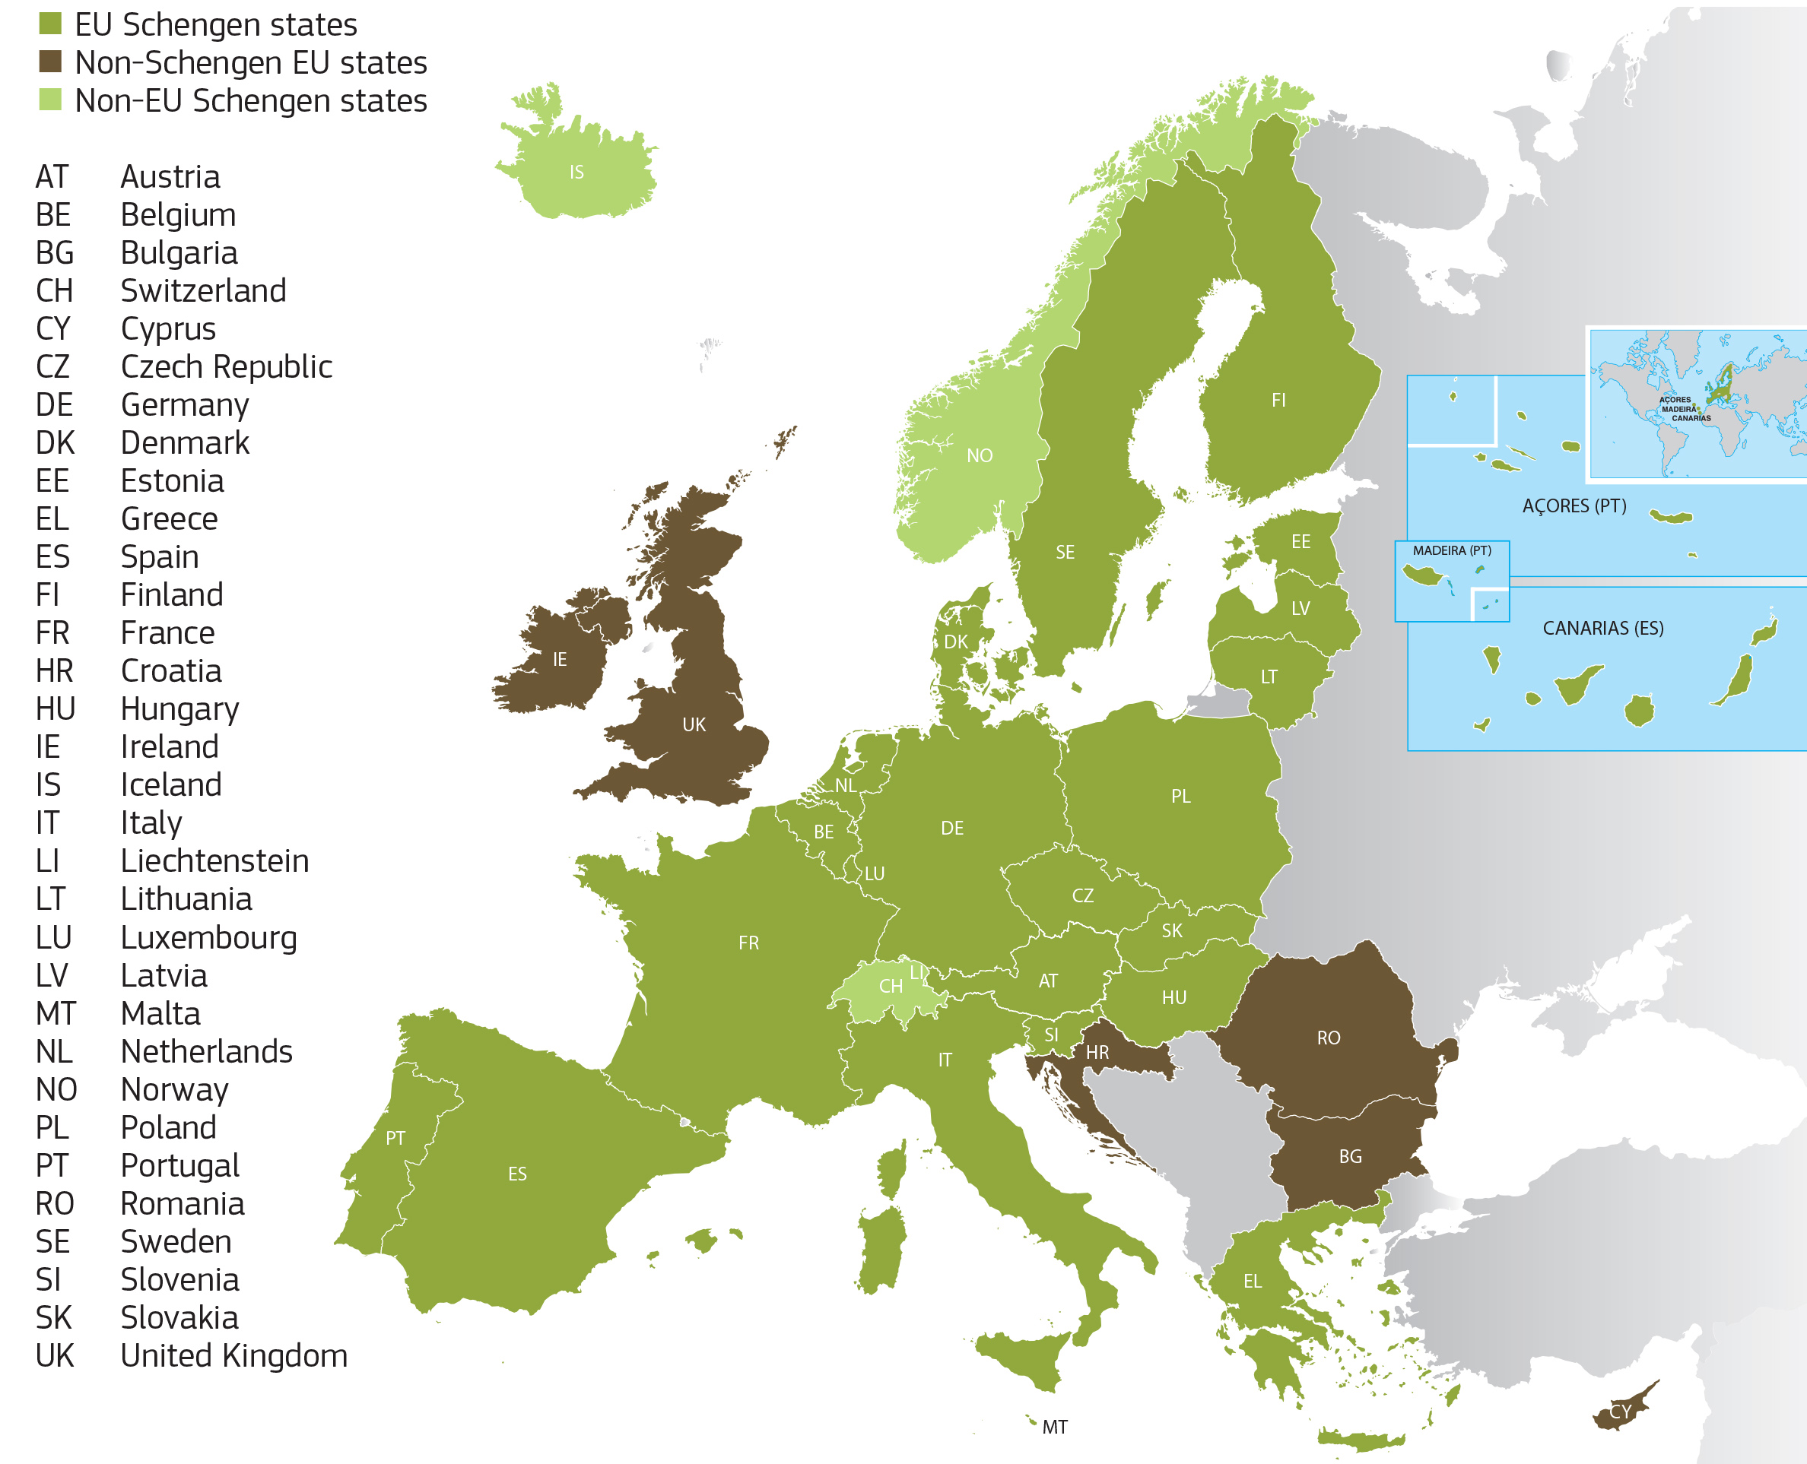
Map of current Schengen Area. Croatia marked in brown pending full admission (Source:EC Migration and Home Affairs).

All of the cases from October show the violent abrogation of these rights, summing up how transit groups in Croatia are really treated by the soon to be Schengen member. The above description (pg 11) has already illustrated the complete violation of asylum access. Along with this, conditions during transport and detention reveal an appalling deviation from legal standards. Ón 6th October (see 2.2) a group from Yemen, Morocco and Egypt were held for several hours in a four by four meter cell before being pushed back.

“It was very bad. It looked like no cleaning for maybe one years. The toilet was full and the smell was so bad.”

Meanwhile on 18th October, a group apprehended by police near Damalj (HR) were stripped to their underwear and driven to a police station in which they were held in a shared cell under observation (see 2.10). The respondent recalls how “they were denied food and water”, and “the officer surveilling them while detained in the cell was drinking alcohol”. After, they were driven to the border with BiH and beaten across it with batons. At the border, one officer dressed in a ski mask swung one person “by the ear and pulled him back and forth while making dog noises”. To these accounts, it is not difficult to see where Article 4 on Fundamental Rights in the SBC is being vagrantly ignored.

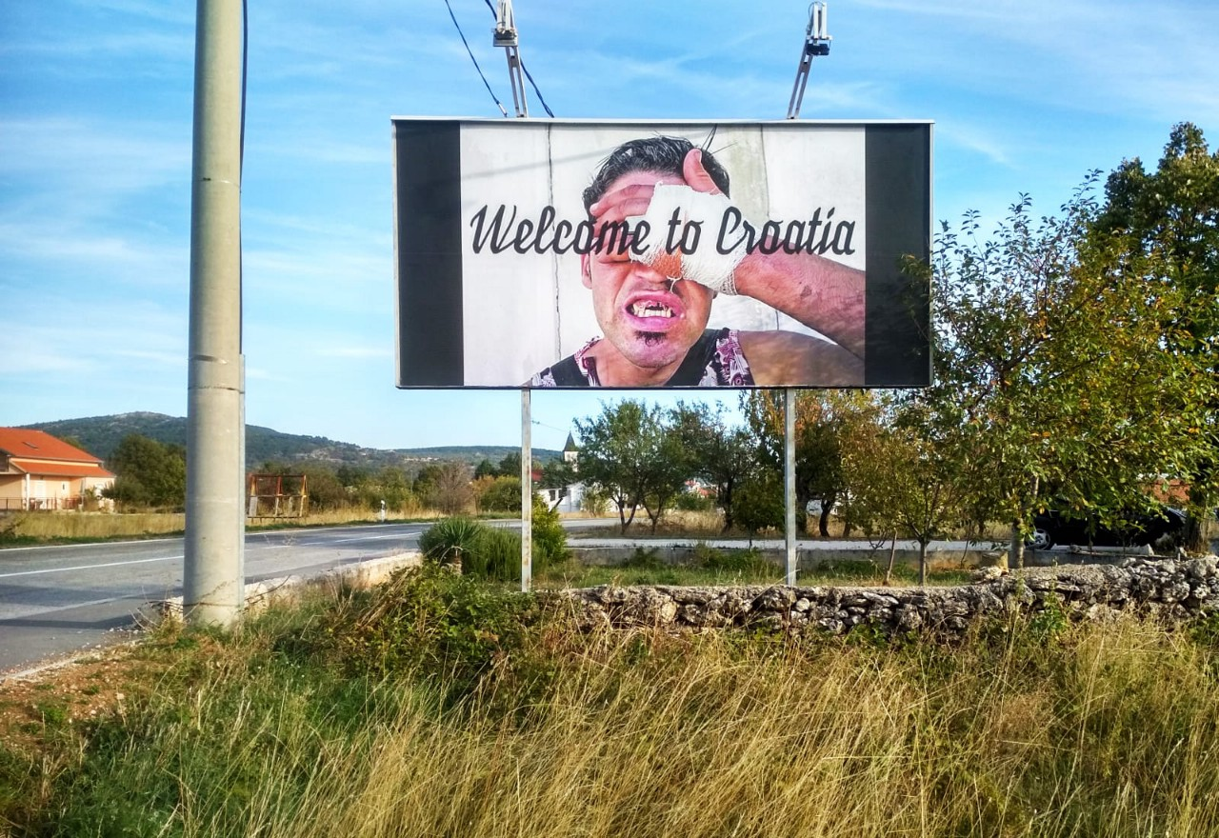
Billboards erected near the HR/BiH border in October (Source:AYS)

As proven, the Schengen Acquis, to which applicant states must prove their adherence, stands diametrically opposed to the daily practice of collective expulsion which Croatia is engaged in. One aspect of this is also seen in the complete lack of any functional monitoring mechanism. While in the Commission's report it was stated that with:

“its commitment to investigate allegations of mistreatment of migrants and refugees at the external borders, Croatia continues to fulfil its commitment in relation to the protection of human rights”

These findings fall foul, suggesting that effective oversight mechanisms and transparency exist. Statewatch asked the Commision in October to explain what constituted such faith in Croatia’s fitness for Schengen, but were offered the same assurances that full “independent monitoring of activities” had been carried out in 2019. This stands in stark contrast to the information provided by organisations in Croatia who asserted in the joint letter “there exists a total lack of official supervision of officer behavior and the National Preventive Mechanism has been essentially disabled”.

Croatia has displayed no ability to meet the demands of the Acquis or the SBC, and the EU Commission has shown a concerning disregard for this, implicating Brussels in the strengthening of violent external border policy. While Croatia’s Schengen Accession paints a fanciful view of what is occurring daily at its borders, in October an intervention by artists and activists drew a far more realistic picture of border management practices. In an apt reply, large billboards posted in the Cista Provo Municipality (HR) read out “Welcome to Croatia and Croatia Full of Torture”.

Whistleblower reveals further internal evidence of MUP malpractice

On October 21st, DNEVNIK.hr published the account of an unnamed police officer who detailed the practice of pushbacks from the perspective of the Croatian police. The whistleblower source confirms many of the border regime’s characteristics which BVMN has been documenting for months. For instance, the officer details how Croatian police units catch people-in-transit “every day, every shift,” loading them into vans and expelling them across the green border to BiH. The officer also admits that Croatian officers are shooting their guns into the air, a profoundly traumatizing experience for people-on-the-move, many who have recently fled war zones (see 2.3). According to the source, shots fired in the air do not qualify as “coercion” under Croatian law, making it harder to challenge such behavior.

However, much of the whistleblowers account does not match the testimonies BVMN has collected. While the officer does admit that Croaitan police are confiscating most personal belongings, he claims that everything except for knives is returned to the people-in-transit at the push-back sites. BVMN has extensively documented that personal belongings are regularly and systematically destroyed and stolen by Croatian police officers (including over 60% of mobile phones during in October). Similarly, the whistleblower maintains that Croatian police have stopped searching migrants for money because they are afraid to catch diseases, when in fact even infants were searched this month by officers (see 2.9).

While it is true that some people-in-transit manage to hide their money, recent reports indicate that people-in-transit are regularly frisked and that money confiscated by Croatian police is rarely returned (see 3.1). Finally, the whistleblower claims that violence, such as beating with batons, is “rare.” Though BVMN’s data set is only a sample range of the suspected thousands of pushback cases every year, reports of excessive violence by Croatian police officers are so pervasive that the whistleblower’s account is unlikely to hold up against the growing body of evidence. Overall, the account confirms the general procedures of the pushback practice, but paints an overly positive picture of Croatian police conduct, excluding systemic evidence of inhumane treatment.

Beyond the account of pushback practices, the whistleblower offers an illuminating account of institutional set-up behind the expulsion of people-on-the-move. He describes that when people-in-transit are detained the arresting officers inform their shift leader about the operation. The shift leader then files an official but falsified account of a deterrent operation, claiming that people-in-transit have been prevented from crossing the border rather than having been returned from inside Croatian territory.

Apparently, a dazzling array of police units are involved in these operations: border guards, police stations, mobile units, emergency police, city police and interceptors on highways with additional assistance from the special police and the intervention units. The hierarchical organization of the push-back regime and the cross-coordination between so many different units of the police force once more shows the deep institutional involvement of the Croatian state in the pushback regime.

Lastly, the whistleblower spoke to the working conditions faced by Croatian police involved in pushback operations. Regular twelve hour shifts and long days walking through difficult terrain is physically draining on the force and puts the officers emotionally on edge. Complaining about scarce food supplies, the officer recounts that officers often have to share what they have brought from home because “[they] are far away from civilization”. Insufficient supplies and over stretched police units are no excuse for the systemic violations occurring. But they do offer additional understanding of the micro politics of borders, where a mandated “hunting” of transit groups is filtered through hierarchical decision makers from Zagreb to Brussels, yet mediated right the way through the MUP system down to provincial policing.

Bosnia

Internal police violence in USK targets people-on-the-move

Western BiH was the site of marked internal violence in October, culminating in the collective route marching of a thousand people from the streets of Bihać to the improvised camp Vučjak. Across the Una Sana Canton (USK), BiH police (who recently called for reinforcement of a reserve corp) have been carrying out a month long operation, targeting informal communities, along with those inside the official camp system, almost entirely halting the movement of people within city limits such as Bihać. Local media USKinfo.ba picked up on the mass removal of people to the camp in Vučjak with the disturbing image of forced marching under police escort. This to a place described by the BBC as a “nightmare”.

The displacement practice has been used several times over the summer, as reported in a recent AYS publication. But the daily seizures began in ernst on the 14th October, after local mayor Fazlic declared that all material aid would be withdrawn from Vučjak. Freedom of movement has been since rescinded, with regular police check points on the roads, and the operations have come with grave allegations of beatings by BiH police. The local administration stated it wished to call attention to the growing crisis in the Canton, but as of publication, the reactionary response is yet to receive any negligible change.
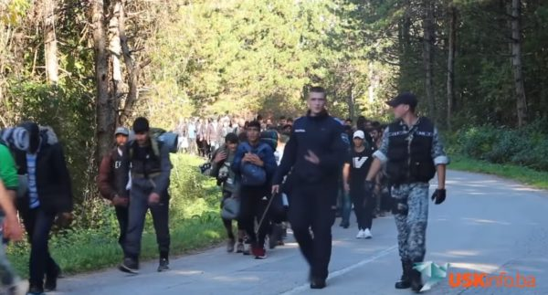
Still of video published by local media of armed police escorting people on foot out of the city (Source:USKinfo.ba).

Instead, muted calls from the EU Commision this month to “relocate as a matter of urgency all the migrants currently in Vučjak”, must be considered in tandem with the ongoing inadequacy of the European funded accommodation centers of Bira and Miral which have also faced the threat of closure. The level of police violence and the poor accommodation frameworks do not bode well for a transit population with limited options for onward travel during the harsh winter months.

To the north, similar dynamics have been unfolding in the vicinity of Velika Kladusa where police also targeted transit groups using public spaces, squats and private housing. In four separate testimonies regarding the internal displacement of people on the move, the respondents all reported that the Bosnian police entered squats and forced out all inhabitants. Following the squat raids police and USK inspectors posted eviction notices on the buildings’ doors. All documents posted were in Bosnian. Within the first few days of the evictions, groups were displaced to Bihac, but after four continuous days of forceful evictions groups were internally displaced to areas surrounding Sturlic. Testimonies taken on these removals reported the police used their fists to violently beat the groups who had been apprehended.

“Some of us ran away, I ran away I did not want them to take me back to Bihać,
but they (the police van) took 6 people.” - quote from Algerian respondent on 22nd October.

“(They) woke us up and put us inside the vans one by one. Then they kick us out in Bihać”
- quote from 32 year old Algerian respondent on 17th October.

Alongside this, the police have recently stemmed the work of the volunteer group No Name Kitchen, and constraints on the Doctors Without Borders field clinic has compounded the lack of support for informal communities on the move. These discordant actions seem to marry up with the impetus to change the current malaise of transit settlements, yet lack of physical accommodation solutions with which to relocate too. This month BVMN published an article analysing this precarious situation, and detailing the lack of adequate reception conditions which arguably determine BiH as an unsafe country to be returning people to.

The impasse is indicative of an EU border politik which has both produced a bottleneck in Western BiH, and outsourced the actions of deterrence to local authorities. This was first achieved through the chronic under resourcing of accommodation sites, but was taken a step further in October with the donation of police vans by IOM to the USK police. It is little surprise that within this chaos, locals have taken to the streets in protest, as reported by Balkan Insight, demanding the reallocation of camp facilities. The brinksmanship being played with the material conditions of people-on-the-move is yet another byproduct of the pushback regime, which has pinned this population down between a violent border and the threat of spending a winter sleeping outside.

Tuzla: Transit site grows in number

October saw continued use of the city of Tuzla, BiH, as a connection between Serbia and USK. With the lack of movement through the central Balkan Route (symbolised by Hungary’s border fence), this link is now vital to groups seeking onward travel via the western route to Croatia. Especially in the growing cold of winter, as people make final efforts at “game” (or return to camps), Tuzla has seen a rise in numbers sleeping in the bus station and growing attention on the site. Locals have self-organised since the start to provide the only support to the population around the station, providing NFIs and food, and operating a welcome service.

A range of groups, including families and a predominance of single males, occupy the semi sheltered eves of the city bus/train station every night. This is particularly notable at weekends, when people need to wait for Monday opening hours in order to register with the Service for Foreign Affairs (SFA). Volunteers estimate there to be a minimum of 30 new arrivals everyday over the last few months, creating a dire need for blankets, clothing and food.

To overcome the situation, locals groups have arranged regular assistance to the population with daily distributions. Constantly present in the bus station, they deliver medical aid, administrative support and offer clothes and showers while the organisations; Merhamet and The Wave Project delivering two meals per day, seven days a week.

More individuals, groups and locals companies have also contributed to this wave of solidarity in the town. Unfortunately, and in spite of the several calls and alerts from locals, the government is yet to respond in kind. No accommodation has yet been installed, which is an immediate solution required given the growing cold and rain which will expose the population sleeping outside and uncovered.

Greece

Partner Report: MIT track violent pushbacks from Greece to Turkey

Mobile Info Team (MIT) are a Thessaloniki based organisation providing asylum information, and are part of the Border Violence Monitoring Network. MIT recently published a report on illegal pushback testimony from the Evros region in Greece. It is here that the river marks the border with Turkey, and where violent pushbacks are a frequent occurrence targeting people-on-the-move.
In the 27 individuals reports, respondents shared strikingly common experiences, including denial of asylum, theft, beatings and forcible expulsion to Turkey. These violent practices which the Greek authorities are involved in are of critical concern. Their reported actions ranged from complicit handovers to ‘commando’ groups, to perpetrating acts of violence and theft themselves. The extent to which the Greek police are involved in the physical act of forcing migrants across the river is still unclear. However, divisions of the Greek police are involved in systematic round up activities in the Evros region, detaining and handing over apprehended groups who are subsequently pushed back to Turkey.
In general, respondents experienced pushbacks in four similar stages:
▪ Arrest and Capture by Greek police inside Greek territory
▪ Detention and confiscation of personal property
▪ Coordinated Handoffs/Transfers to Authorities
▪ Collective expulsion across the Evros river
Every pushback is inherently illegal, regardless of whether the individual also suffered violence and deprivation during the act. Fair procedure is completely suspended and pushbacks often violate the principle of non-refoulement, fundamental to international law, by removing people to state territories where they are at risk.
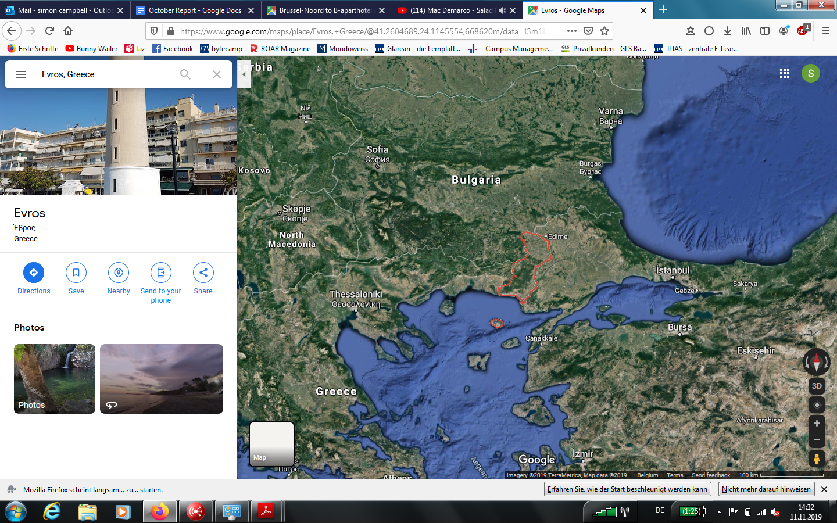
Map of Greek-Turkish border, Evros region marked in red (Source:Google Maps).
Many reports over the last few years have covered deportations from Turkey to Syria, but as shown in a recent report published by Amnesty International, “recent domestic developments seem to have given an added impetus to this illegal refoulement,” including the Turkish government’s plans to establish what is referred to as a demilitarized “safe zone” along the border in Syrian territory of about 20 miles. This is meant to serve the relocation of a partial amount of the large Syrian refugee population in Turkey.
The pushbacks have played out in the political discourse between the Turkey and Greece, as in October when the Ankara administration urged an end to the pushbacks from the Evros border region. The Turkish Foreign Ministry claimed that over 25,000 irregular migrants have been pushed back from Greece in 2019, over double the amount in the previous year. Greek Prime Minister Kyriakos Mitsotakis hit back at these claims, accusing Turkey of actively feeding into the spike of crossings attemped to the Aegean islands after a three year period of steadily decreasing arrivals. In October, after several incidents of unrest and fires, Greece made a commitment that they would curtail the overcrowding on the Aegean islands by sending 10,000 migrants back to Turkey by the end of next year.
These developments offer incentives on both sides to continue the pushbacks, indicating that there this is a trend that will continue, and even scale up. The most recent rhetoric of responsibility shifting does not create a positive breeding ground for the prevention of pushbacks.
Within the systematic nature of the pushbacks and the risk of chain refoulement to Syria, the testimonies collated by MIT also demonstrate a disregard for human rights and detail the use of inhumane treatment. Respondents reported were forced to drink toilet water, detained in overcrowded makeshift jails, suffered routine theft and destruction of personal property, beatings, humiliating searches and electrical shocks. One respondent shared that he and his family were held in a small, stark, crowded and smelly room during detention. While another female respondent explained that after having their phones removed, her family was placed in detention and held without food or water, noting that they were denied milk for the child and upon requesting water the family was told by police:
“‘Drink the toilet water’, so we were forced to prepare dirty water’”.
Another respondent shared that he became “sick from drinking the toilet water, but we didn’t have any other choice at the time”. Physical abuse was a common factor in many stories. Respondent Q.K. explained that they were intercepted and taken to the Turkish border by car. When they got out the respondent said
“…I was holding my son, my wife was holding my daughter and-without any mercy or empathy-they hit both of us”.
This treatment is nothing new, but has reached shocking levels in the reported period covered by MIT. The report calls urgently for an immediate stop to these illegal pushbacks, and a review of all current procedures at the land border to ensure that they comply with international laws and human rights, including Article 33 of the 1951 Convention and Article 3 of the European Convention on Human Rights (ECHR). People-on-the-move must be afforded individualised and fair access to international protection, and border practice realign with the states legal obligations to guaranteeing the safety, dignity and rights of people in transit.

Update on new Greek asylum law

On 31st October, the Greek government passed a new refugee law titled ‘International Protection and other Provisions’, curbing the rights of asylum seekers in an attempt to remove people from the country and to dissuade entry of others. The 237 page Act was passed after less than four days of consultation, and will come into effect in two months on the 1st January 2020.

The Act has a number of worrying implications for refugees, migrants and asylum seekers and has been widely criticised by human rights organisations for breaking international humanitarian law and worsening the situation for vulnerable groups in Greece. Some of the most concerning developments are those in the health-care system, the promise of increased deportations, and the formal introduction of the police and military into the asylum interviewing process.

The Greek government illegally and unofficially discontinued the AMKA medical system earlier this year, leaving migrants and refugees without access to healthcare outside of emergency cases. They have now proposed to replace this system with the ‘Aliens Healthcare Card’ (CSFP). The problem is that the CSFP does not currently exist. The Greek asylum system is strained and running at full capacity as it is; to build an entirely new system in two months seems unrealistic. The empty promises of the new Helios housing programme left people-on-the-move without adequate shelter. Now in October, concern is that the CSFP system will also follow suite, leaving thousands without recognised access to health care.

Last month, the New Democracy government pledged to deport 10,000 migrants by the end of 2020. In the most openly anti-refugee section of the Act, the government states its plans to create a list of ‘safe countries of origin’ and ‘safe third states’ in a clear attempt to force asylum seekers back to Turkey or, in some cases, to the countries from which they fled, places like Algeria and Morocco. It is illegal under international law to refuse to consider an asylum application based solely on country of origin, and this is essentially what this section of the Act intends to do.

Further compounding this unjust system is the shifting locus of power from the Greek Asylum Service (or European Asylum Support Office) to the Greek police and army personnel in the asylum application process. Not only are these groups improperly trained in interviewing and decision-making, but they have also been heavily implicated in the practices of illegal push-backs. In the face of violent crackdowns on squats in Exarchia, Athens, and increased reports of police brutality in Thessaloniki over the past few months, the decision of the government to grant police officers even more autonomy over the fate of refugees and migrants is perhaps the most worrying development the Act puts forward.

Slovenia

Interconnected Borders: Joint border patrols and regional policy

Slovenia continue to participate in multiple joint border projects. Last month it was announced that the implementation of the agreement on shared border patrols with Italy will be renewed at least in the Koper police department. Cases from this specific area are still a minority, but as with a report from this month (see 1.3), the heightening of controls on foot and vehicle movement might suggest this collaboration is starting to play a more proactive role in stemming movement at the top of the Balkan Route.

Further south east, the Slovenian Interior Minister Boštjan Poklukar met his Serbian counterpart Nebojša Stefanovic in Belgrade on the 21st of October to discuss bilateral ties and migration control. The two agreed on the necessity to improve the collaboration between Slovenian and Serbian police forces, which is already taking place. As discussed in earlier BVMN reports, this approach of externalisation has an uncomfortable common ground with nationalism, authoritarian governance, and demands for hard borders. Tellingly, this tendency does not seem contradictory with calls for EU expansion, as Pokuklar said, he supported the accession of Serbia to the community. In short, the rise in retrograde border controls - as seen with the case of Croatia - seems actually to develop in tandem with integration into the EU, despite the profound legal incompatibilities.

In this frame, the speech of Croatian prime minister Plenkovic, calling on October 25th for an agreement with Turkey over migration control is of note. It sets the sights of Croatia on curbing the flow into the Western Balkans, melding national interest with the clearly Brussels steered prerogatives of externalisation. This was complemented by the EU in October with the recruitment drive for a new Frontex “standing corps” which will be enabled to carry our independent operations in the regions non-member states. In conjunction with Slovenian policy, these developments illuminate an ongoing strategy which makes use of bilateral and transnational ties in order to stem migration within the constituent parts of the route.

Serbia

Fire in Sid sees local police target informal communities

In October, a timely reminder came of the risks to transit populations within Serbia, a territory not 'safe' to be returning people. The burning of a tent settlement by police in woodland near Serbia's border with Croatia, adds to the numerous other arson attacks aimed at informal communities of transit, as seen in 2018 in Subotica. An encampment close to the Tovarnik (HR) border crossing (45 ° 08'18.5 "N 19 ° 10'55.2" E), home to 35 Afghans - seven of whom were minors - was targeted by Serbian police forces on the morning of October 21st 2019 at around 10:00.

The fire completely destroyed the settlement, and it is fortunate that nobody was hurt given the extreme dangers of arson when directed at the flammable nylon of tents. A criminal complaint filed by the Belgrade Centre for Human Rights lists allegations of a suspected arson and damage to property, carried out by Serbian authorities. It states that two border officials appeared at the settlement, which resulted in the fleeing of the migrants present at the time. The inhabitants remained close to watch however and allege that an officer - identified as a member of the local police department - was called by the present officers, bringing with him jerrycans of gasoline which they then proceeded to pour on the remaining possessions setting them alight.

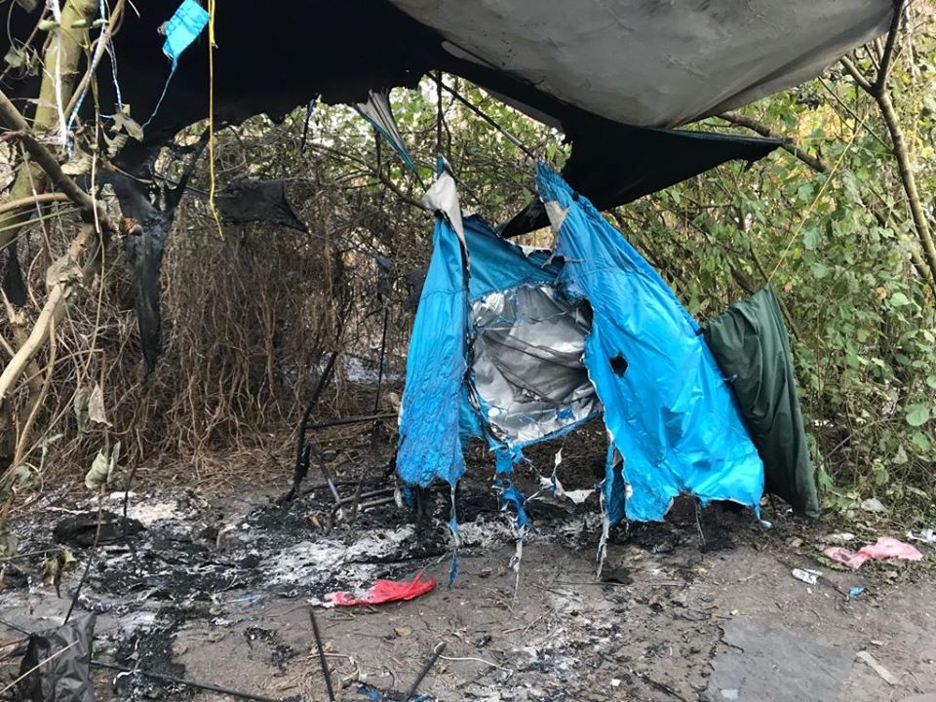
Remnants of camp site near Sid, burnt by Serbian police (Source:NNK)

This included a total of 20 tents, two mobile phones, one Quran and 290 euros, as well as a great quantity of clothing and blankets. The inhabitants lost the entirety of their possessions and it should be noted that they at no point received any preliminary information on the impending police enforcement, neither being prompted to break up the camp, nor to report to an asylum reception centre. Following the respondents statements, they were forced to withdraw at gunpoint by the officers, as they tried to re-enter the campsite to salvage their scorched belongings.

The attack bears a double edge, revealing the true precarity of transit in Serbia as winter arrives. While police consistently attack informal sites, access to the nearby camps of Principovac and Adaševci are also pressured with constraints on winter registration. Therefore the authorities place people-on-the-move in an intentional limbo, which can only be seen as an effort to clear the population from the area. Combined with the Croatian pushback regime, this secondary and internal displacement is a final and crushing indignity. Five pushbacks at this border area were recorded by BVMN in October. All of these respondents were directly affected by the fire, which forced inhabitants to merge with another large squat, also the subject of recent police raids as covered in September.

Montenegro

Frontex Status Agreement signed with Montenegro

An agreement was signed in early October between the state of Montenegro and The European Border and Coastguard Agency (Frontex). The treaty allows Frontex to “carry out deployments and joint operations on the territory,” as seen since May 2019 with the first agreement of this kind reached in Albania. The development sits within a regional strategy of European force deployment beyond bloc territory, including pending agreements with Bosnia-Herzegovina, Serbia and North Macedonia. Importantly, the agreement allows Frontex not only to participate in joint operations, but to deploy its own teams in Montenegro, lauded as a major step in “tackling illegal immigration.”

This autonomy of the external agency is worrying however, not least because contributing member states will see their personnel “enjoy immunity from the civil and administrative jurisdiction of Montenegro”. Situated in a critical midpoint between the transit hubs of Greece and the northern departure points of BiH, Montenegro plays an important link point in the movement of people up the West Balkan Route. This transit has come under domestic constraints since 2018, with added deployment of border police and the stationing of army units. With the impending arrival of Frontex, it appears that Montenegro will become an even more active stage for the externalization of Europe’s borders.

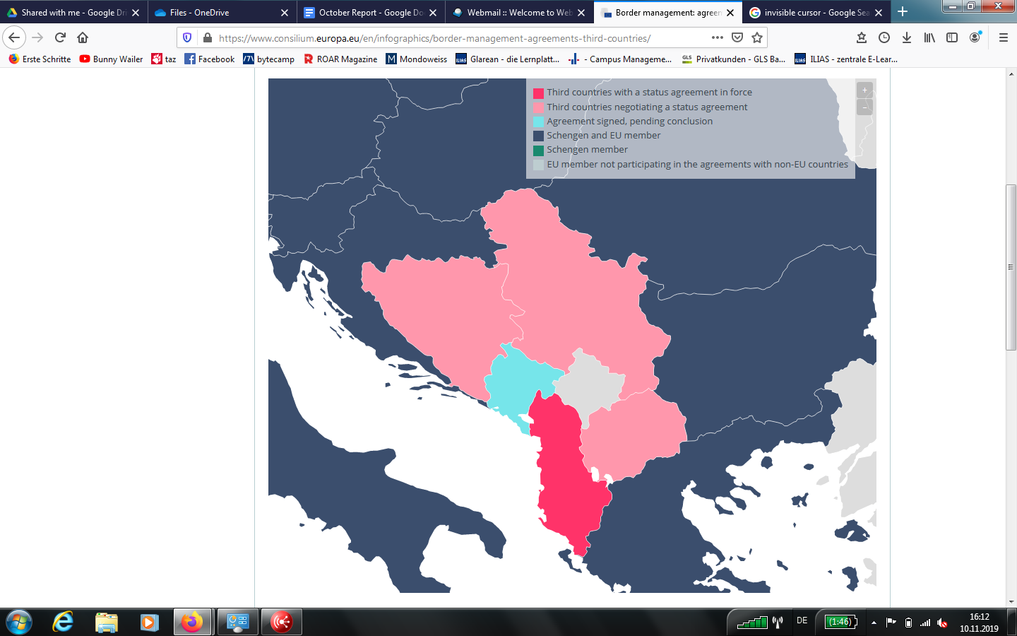
Montenegro marked in light blue. Serbia, Bosnia-Herz., and N. Macedonia in pink and Albania in red (Source: European Council).
Albania
Frontex in Albania play apprehension role
This month, the German TV Arte published a video about the Frontex mission in Albania, which has been running since May 2019. The first Frontex mission outside EU territory has been launched to “tackle illegal migration” on the Albanian-Greek border. According to the video, over 2.000 migrants have been arrested by 50 Frontex officers from twelve EU member states, with the help of vehicles and a night vision camera van. As shown in the video, the proceeding of Frontex officers at the green border is detecting irregular migrants, arresting them and handing them over to local border guards.

In response to accusations of push-backs being carried out by Albanian authorities, Frontex spokesperson Izabella Cooper states: “Push backs are illegal. I would like to clarify that Frontex is not in power over the behaviour of the national border guards.” This statement leads to severe concerns about the Frontex procedure on the border, as it is not does not preclude their direct involvement in initiating a pushback via apprehension. The footage, which shows a Frontex official detaining a transit group of five, adds further weight to the questions raised recently as to whether Frontex is “arranging” pushbacks through surveillance.

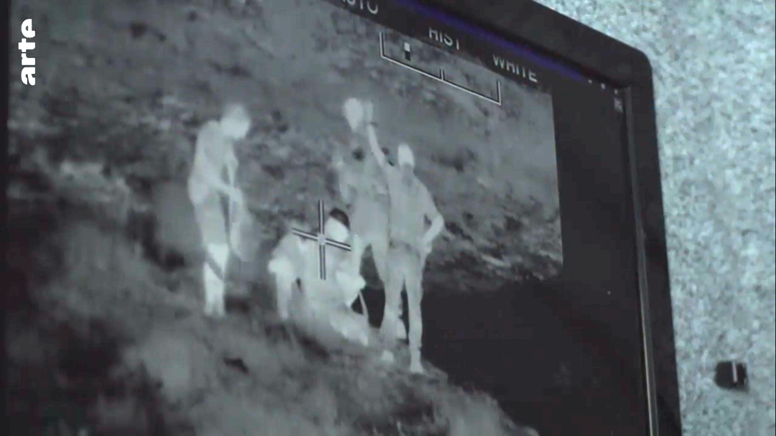
Still image, video monitor from night vision surveillance van operated by Frontex in Albania (Source:Arte).

Glossary of Reports, October 2019

The Border Violence Monitoring Network recorded 30 interviews on pushbacks during the month of October, covering 29 separate incidents. Two interviews covered the same incident, and are combined in case 2.1. The ranging transit group size meant that some incidents involved just one person, while others included 150+. The total number of people pushed back is recorded at 464, but estimates from respondents on some of the larger group sizes bring this number up to 607. The table below represents data of the minimum number of people present in each group. 24 cases were pushbacks to BiH (five chain pushbacks from Slovenia, and nineteen direct pushbacks from Croatia). Five pushbacks were to Serbia (one chain pushback from Slovenia, and four direct pushbacks from Croatia. The reports were conducted with a wide demographic variety of respondents including adults and unaccompanied minors (as young as 10 months old), men and women. The respondents in these reports also originate from a wide variety of places including Algeria, Morocco, Western Sahara, Yemen, Iraq, Tunisia, Syria, Egypt, Palestine, Iran, Pakistan and Afghanistan.

Slovenia to BiH
1.1 | 1st October | 2nd October | 5 | Algeria
1.2 | 1st October | 2nd October | 5 | Algeria
1.3 | 7th October | 12th October | 6 | Syria
1.4 | 15th October | 15th October | 3 | Syria
1.5 | 24th October | 28th October | 24 | Yemen, Western Sahara
Croatia to BiH
2.1 | 30th September | 12th October | 150 | Syria, Iraq
2.2 | 6th October | 13th October | 4 | Yemen, Egypt, Morocco
2.3 | 9th October | 14th October | 43 | Iraq, Egypt, Syria, Pakistan
2.4 | 12th October | 26th October | 4 | Algeria
2.5 | 14th October | 29th October | 35 | Palestine, Syria, Iraq
2.6 | 15th October | 17th October | 4 | Algeria
2.7 | 15th October | 17th October | 7 | Morocco
2.8 | 15th October | 22nd October | 50 | Afghanistan, Pakistan
2.9 | 16th October | 26th October | 8 | Palestine, Syria
2.10 | 18th October | 20th October | 4 | Morocco
2.11 | 18th October | 20th October | 7 | Palestine, Syria
2.12 | 20th October | 20th October | 4 | Morocco
2.13 | 20th October | 21st October | 10 | Yemen, Iraq
2.14 | 22nd October | 22nd October | 13 | Algeria, Pakistan
2.15 | 22nd October | 29th October | 36 | Syria, Algeria
2.16 | 24th October | 25th October | 1 | Tunisia
2.17 | 25th October | 29th October | 15 | Syria
2.18 | 26th October | 28th October | 3 | Algeria
2.19 | 27th October | 28th October | 7 | Morocco
Slovenia to Serbia
3.1 | 26th October | 30th October | 2 | Iran
Croatia to Serbia
4.1 | 15th October | 16th October | 4 | Afghanistan
4.2 | 16th October | 17th October | 3 | Afghanistan
4.3 | 26th October | 26th October | 3 | Afghanistan
4.4 | 26th October | 26th October | 4 | Afghanistan
More reports from previous months can be found here.

Network structure and contact

The Border Violence Monitoring Network is a volunteer led endeavour, relying on the efforts of participant organizations working in the field, in advocacy and in litigation. The Network receives grant funding from The Open Society Foundations, supporting three paid positions, and volunteer travel expenses.

To follow more from the Border Violence Monitoring Network, check out our website for the entire testimony archive, previous monthly reports and regular news pieces. To follow us on social media, find us on Twitter handle @Border_Violence and on Facebook.

For further information regarding this report contact: mail@borderviolence.eu
For press and media requests please contact: press@borderviolence.eu

